Detalles:
Actualmente se encuentran en 262 Holloway Rd., Londres, N7 6NE, Tel. 020 7686 8666, Fax. 020 7686 8667.
Email: admin@nafsiyat.org.uk
Website: www.nafsiyat.org.uk
Su orario de apertura es:
Lunes: 9.30am - 8.30pm
Martes: 9.30am - 5.30pm
Miércoles: 9.30am - 8.30pm
Jueves: 9.30am - 5.30pm
Viernes y fines de semana: cerrado
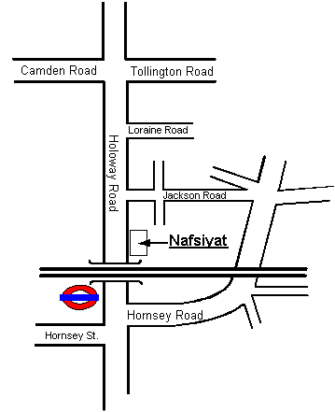
The nearest bus stop/station to the centre
The nearest stations are Holloway Road Underground (Piccadilly Line) and Drayton Park Overground. Buses available are 253, 153, 43, 279, 259 and 29. There is local parking, however this is very restricted.

